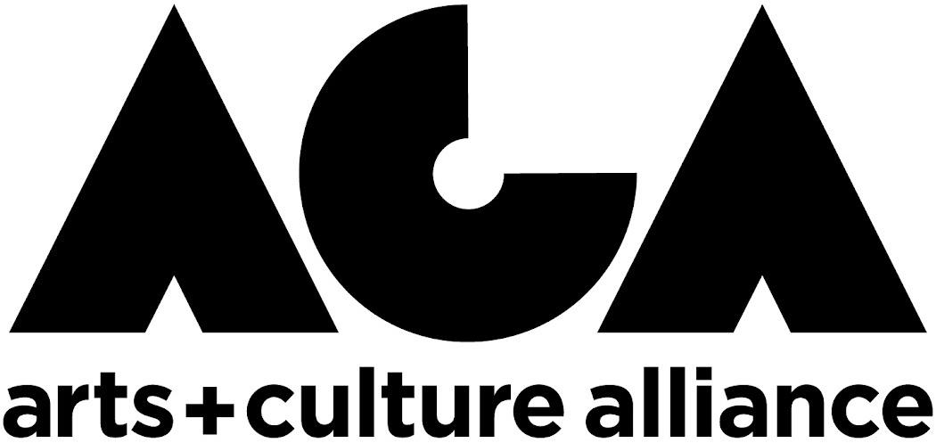

**ORGANIZATION INNOVATION GRANT**

*Preview Application Questions*

*Please note, applications must be submitted through our online google form.* Applications will not be accepted in any other format (i.e. email, mail, etc.). *Please use this document as a preview of what to expect and/or a way to easily download the questions to your computer to answer the questions offline.*

1. Organization and Contact Information
2. Describe the idea you are proposing. What will success look like? How does this idea connect to the Arts & Culture Master Plan? Is there a specific Placemaking Theme your idea ties to? (2500-character limit)
3. Identify your target audiences. Outline a clear path to how you plan to reach those audiences. Will you reach communities by partnering with their trusted organizations and/or community leaders? (1200-character limit)
4. List a site location for where your community/audience engagement will take place. Keep in mind that we are looking for projects that occur outside of your typical location. (750-character limit)
5. Describe how this project fits into your organization’s mission and purpose. (1250-character limit)
6. Please list the total dollar amount requested (the amount cannot exceed $5,000). Please also provide an overview of how you intend to allocate those funds--format should be a simple list of line items with associated cost. (1200-character limit)
7. Please provide a work plan and timeline. (750-character limit)
8. Optional:
   1. You may have decided to take one of your current or recent programs out into the community. If this is the case, you can provide additional information, website links to online documentation, etc. in the space below. (1200-character limit)
   2. Please provide any additional information you think we think we should know. (1,200-character limit)

**QUESTIONS?**

Contact the ACA’s Executive Director, Amber Danielson, at [director@artsandculturealliance.org](mailto:director@artsandculturealliance.org) well in advance of application deadlines if they have any questions regarding the program.