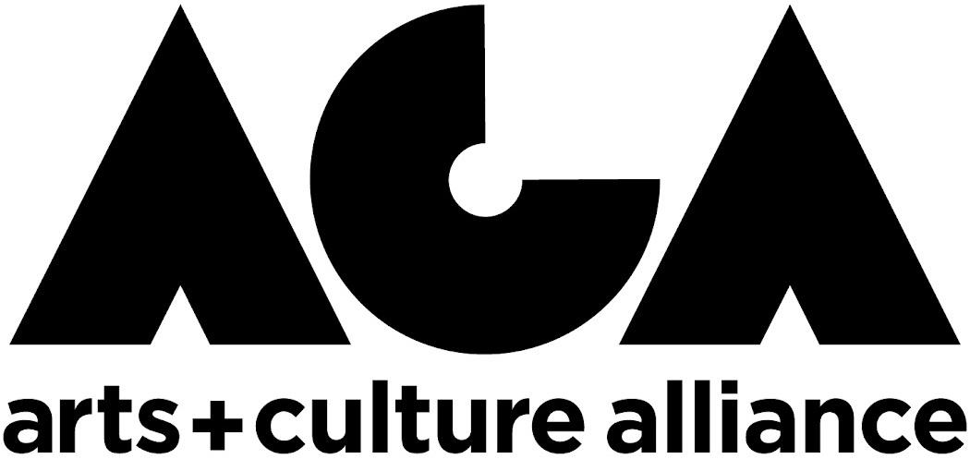

**ARTIST INNOVATION GRANT**

*Preview Application Questions*

*Please note, applications must be submitted through our online google form.* Applications will not be accepted in any other format (i.e. email, mail, etc.). *Please use this document as a preview of what to expect and/or a way to easily download the questions to your computer to answer the questions offline.*

1. Contact and Demographic Information
2. The [Marshalltown Arts and Culture Master Plan](https://artsandculturealliance.org/wp-content/uploads/2023/04/MarshalltownArts_MasterPlan.pdf) identified five themes. Identify which Placemaking Theme will be the inspiration of your project

1. Describe the project you are proposing. What will success look like? Please provide a work plan and timeline. Also include any partners, community engagement, etc. you plan to include as part of your project. (1200-character limit)
2. How does this project relate to your artistic practice? How might this project strengthen your artistic work and practice? (750-character limit)
3. When and where do you intend to engage community/audience with your project? Will your project be free to the public? (750-character limit)
4. Please list the total dollar amount requested (the amount cannot exceed $3,000). Please also provide an overview of how you intend to allocate those funds--format should be a simple list of line items with associated cost. (1200 Character Limit)
5. Optional:
   1. CV / Resumé
   2. Three representative work examples

**QUESTIONS?**

Contact the ACA’s Executive Director, Amber Danielson, at [director@artsandculturealliance.org](mailto:director@artsandculturealliance.org) well in advance of application deadlines if they have any questions regarding the program.